

Chapter 02: Graph Theory

Higher nationals in computing

 BCAS Campus, Kalmunai

By: Eng.A.L. Jubailah Begum

Discrete maths

**Cartesian co-ordinate systems in two dimensions.**

• origin

– where x-axis crosses the y-axis, in a 2-dimensional world;

or where x-axis, the y-axis and the z-axis all intersect, in a 3-dimensional world

– known as the point (0, 0) (or “coordinate pair”), in a 2-dimensional world;

or as point (0, 0, 0), in a 3-dimensional world

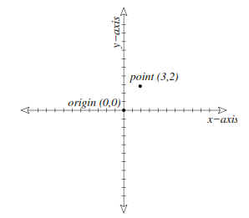

Example: 2-dimensional Cartesian coordinate system

**Representing lines and simple shapes using co-ordinates.**

functions and equations

1. **Lines**

• a function expresses the relationship between 2 (or more) variables. Typically, a function is written in the form of an equation—two things on either side of an equals sign (=)

• a typical equation has one variable on the left side of the equals sign, and an expression containing another variable on the other side of the equals sign; for example: equation of a line:

**y = mx + c**

• in this case, y is called the dependent variable, because its value depends on the value of x (the independent variable). this is a single-variable function, because there is only one independent variable.

• the values m and c are called constants. they may also be called coeﬃcients. their values do not change. m is considered to be the gradient (slope) of the line and c is the cutting point of the line on the y axis.

• thus, given any value of x, and constant values for m and c, you can use algebra to

determine the value of y. for example, if:

y = 2x + 1

and x = 3, then

y = 2(3) + 1 = 7

• you can create a graph of the function by computing some of the values for y, given

selected values of x. for example:

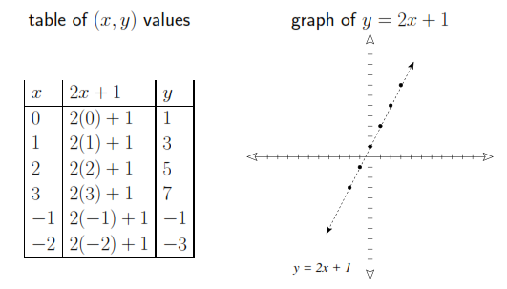

• you might see the same thing written as f(x) = 2x + 1, in which case the notation f(x)

takes the place of y. Here m (gradient or slope) = 2, c (cut point) = 1 (you can observe it on the graph above)

• NOTE: for simplicity, we ﬁll focus only on 2-dimensional environments in this class.

1. **Circles**

• a circle is deﬁned by its center and its radius

• the circumference (or “perimeter”, i.e., distance around the edge) of a circle is 2πr

• the diameter of a circle is equal to 2r

• a circle inscribes an arc of 2π radians or 360® (degrees)

thus, 1® = 2π/360 = π/180 radians

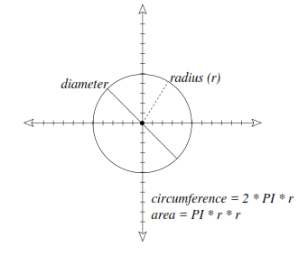

Angles

• an angle is deﬁned by two lines that share one endpoint

• angles are measured in degrees or radians

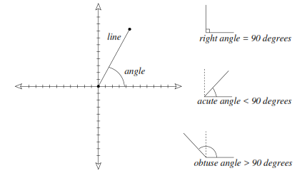

1. **triangles**

• a triangle is deﬁned by three points

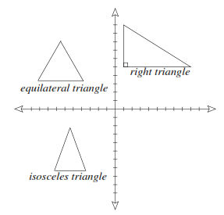

– the perimeter of a triangle is the sum of the length of its 3 sides

– the area of a triangle is 1/2 × base × height

– the sum of the angles of any triangle = 180®

• we note three special kinds of triangles:

– equilateral (all sides are the same length; all angles are 60®)

– isosceles (two sides are the same length)

– right triangle (one of the angles is 90®)

**useful equations**

